7.4 USE OF SELF KEYWORD
- Self keyword is the first parameter among the rest of parameters in class attributes list
- It is not possible to give values to self keyword directly
- Self keyword gets value from python itself when it gets called along with function
- Self keyword also used to represent instance of class
- Self keyword is mainly used to bind the attributes with the given arguments
- Self keyword acts like pointers in c++which refers to instance variables.
7.5 USE OF __init__ CONSTRUCTOR
- __init__ is a special method used in python.
- __init__ is automatically called only when memory allocation has been given to new object
- __init__ is also used to initialize objects state which contains set of statements and instructions
- __init__ will run once, when object for a class is instantiated.
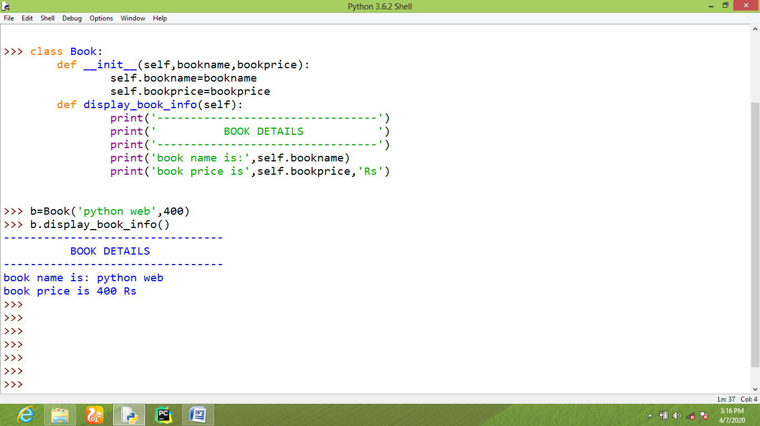
7.6 PROPERTIES OF OOPS
7.6.1 Data Abstraction
7.6.2 Data Encapsulation
7.6.3 Polymorphism
7.6.4 Inheritance
7.6.1 Data Abstraction
  - Data abstraction stands for the process of showing only necessary details and hiding the unwanted program’s function implementation details.
  - Data abstraction is also called as data hiding process.
7.6.2 Data Encapsulation
  - Data encapsulation stands for both data hiding and dynamic binding.
  - Here, data hiding is the ability to hide unnecessary implementation.
  - Dynamic binding stands for assigning values to the declared parameters.
  - In common, data encapsulation is the process of creating objects for a specific class and giving input values to the same class instantiation at the same time.
7.6.3 Polymorphism
  - Polymorphism is similar to homograph in English communication
  - Polymorphism means same name with different behaviors and responses in a particular class.
7.6.4 Inheritance
- Inheritance is the process of achieving and accessing all the functions and attributes of base class from different child classes.
- Based on the number of child classes in python different types of inheritance used are,
    - Single inheritance
    - Multiple inheritance
    - Multilevel inheritance
    - Hierarchical inheritance
Single Inheritance
If a child class is inheriting properties and attributes from a single parent class is called single inheritance.
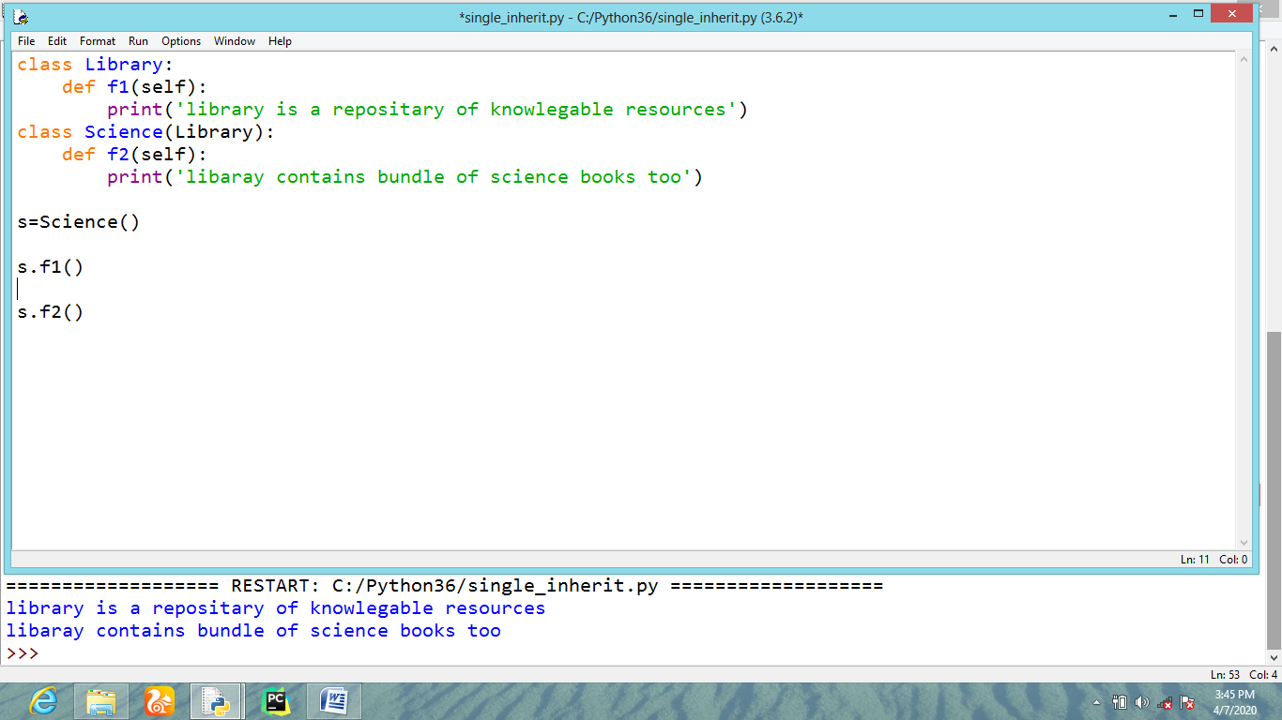
Multiple inheritance
If a child class inherits properties and attributes from more than one base class is called multiple inheritance.
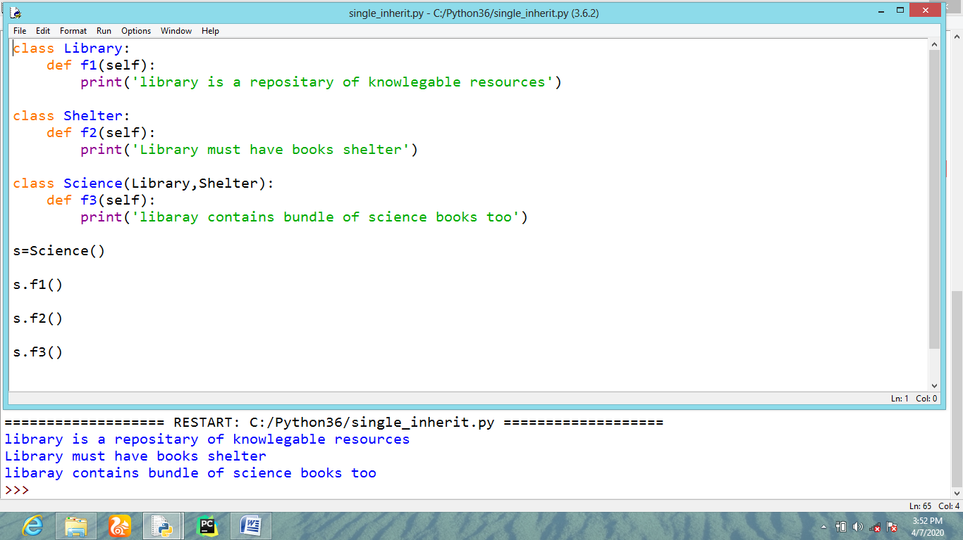
Multilevel inheritance
If a child class will become a super class for another child class is called multilevel inheritance.
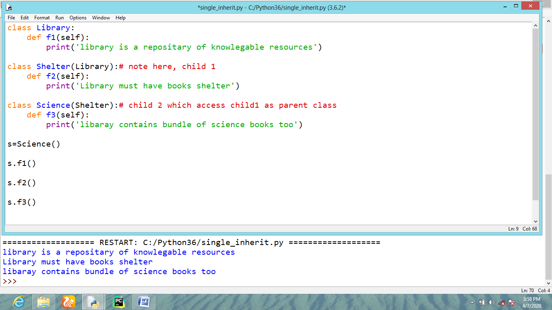
Hierarchical inheritance
If multiple inheritance occurs within same base class or child class is known as Hierarchical inheritance.
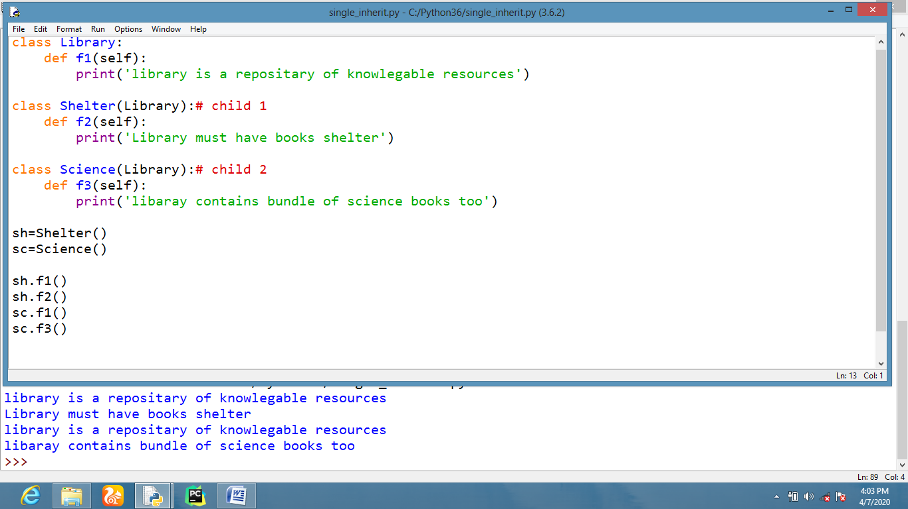
Sample coding for class with __init__constructor
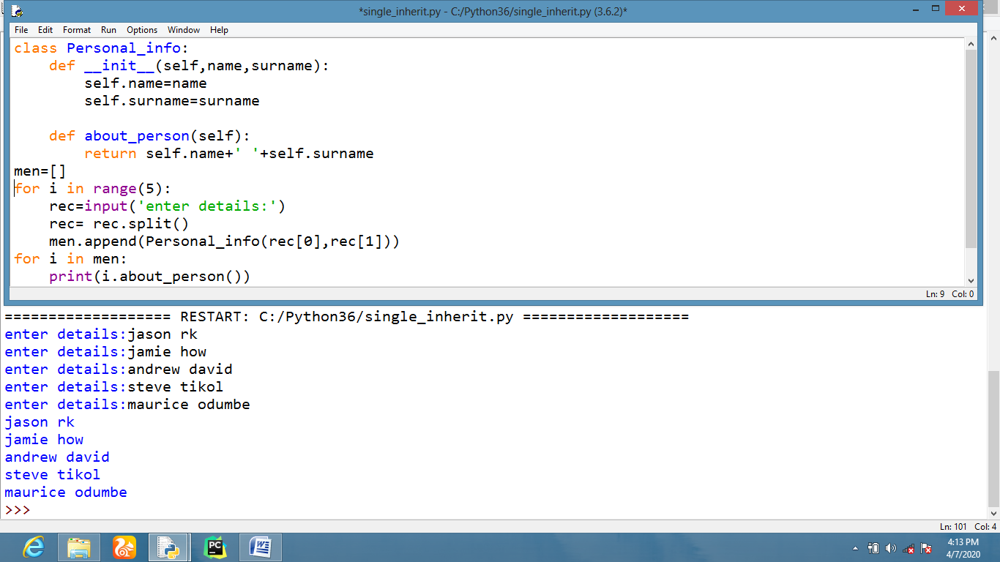
Sample coding for Polymorphism
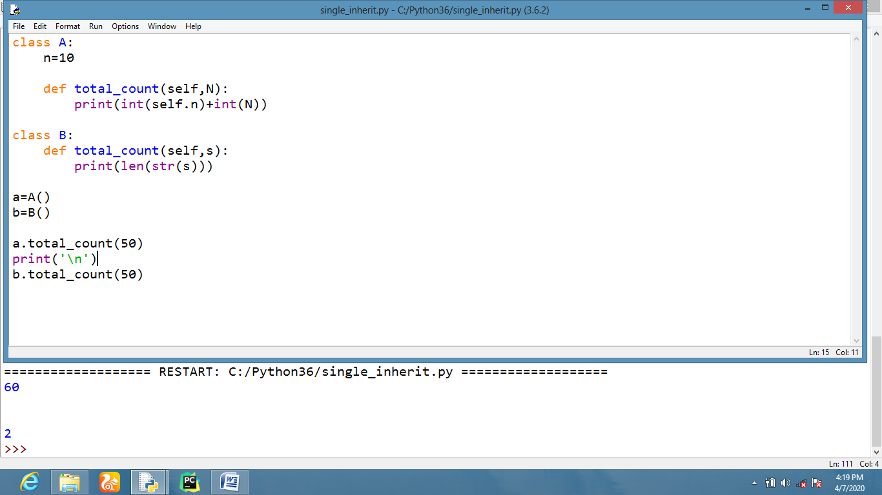
Sample coding of Reloading operator for addition
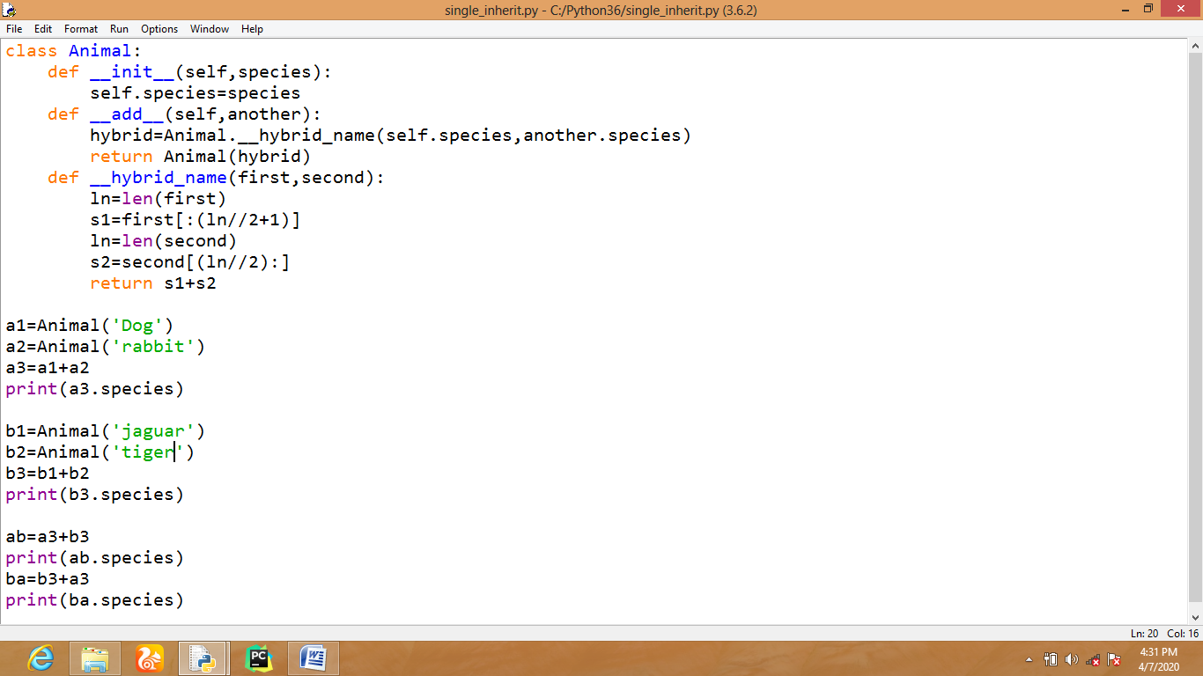
Output will be like,
Dobit
Jaguger
Dobuger
Jagubit

